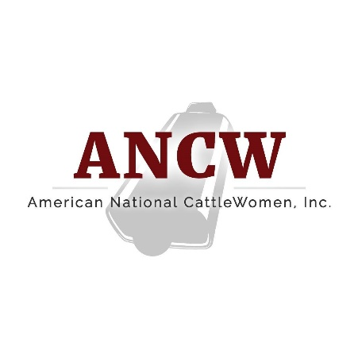

American National CattleWomen
16799 Prairie Circle · El Reno, OK · 73036
February 7, 2022
For more information:
Cheyenne Sparks, ancw@ancw.org

Pamela Griffin named President-Elect of the American National CattleWomen
HOUSTON – Arizona CattleWoman, Pamela Griffin has been named the American National CattleWomen (ANCW) President-Elect. Griffin, of Globe, AZ., was named to the position at the 2022 Cattle Industry Convention in Houston, Jan. 31, 2022. Over the next year, Griffin will support the initiatives of the ANCW along with fellow officers President Reba Mazak of Florida and Vice President Ruth Coffey of Oklahoma.
Griffin was born in Anaheim, California surrounded by strawberry fields and orange groves. In 1974, the family moved to Arizona, landing in Carefree. Both parents left agricultural roots. Her father’s family ran a farming and meat operation, and her mother’s side ran the family’s grain operation. Griffin grew up on what she considers a hobby farm. As an adult, she worked in the legal field as well as commercial and residential real estate development.

In 2008, she met her husband John Griffin. They live on Griffin family’s third-generation 110-year-old cow/calf operation, Griffin Cattle Ranch and started their own cow/calf operation, X4 Cattle Company, LLC. Together, they are pursuing the custom beef industry.

She has served in numerous capacities, including: Gila County Cowbelles President, Arizona State Cowbelles President, Board Member of Arizona Cattle Industry Research and Education Foundation, Board Member- Gila County and Arizona State Cattle Growers, and past honorary member of the Arizona Beef Council Board. She is a graduate of Project CENTRL for Arizona Rural Leadership Class XXIII. In 2019, she was the inaugural recipient of the Governor’s Award for Outstanding Arizona Woman Rancher awarded by Governor Doug Ducey.

Griffin believes that her involvement in the cattle industry comes with larger obligations and responsibilities, including learning from others, staying up-to-date on current events and becoming an active advocate in the industry by sharing her voice. She is truly humbled by and thankful for the opportunities that have presented themselves along her journey and the people who have mentored and welcomed her along the way.
###
American National CattleWomen is a voice for women who share a passion for the beef community with focus areas in beef promotion, education and legislation. For more information, visit www.ancw.org.

